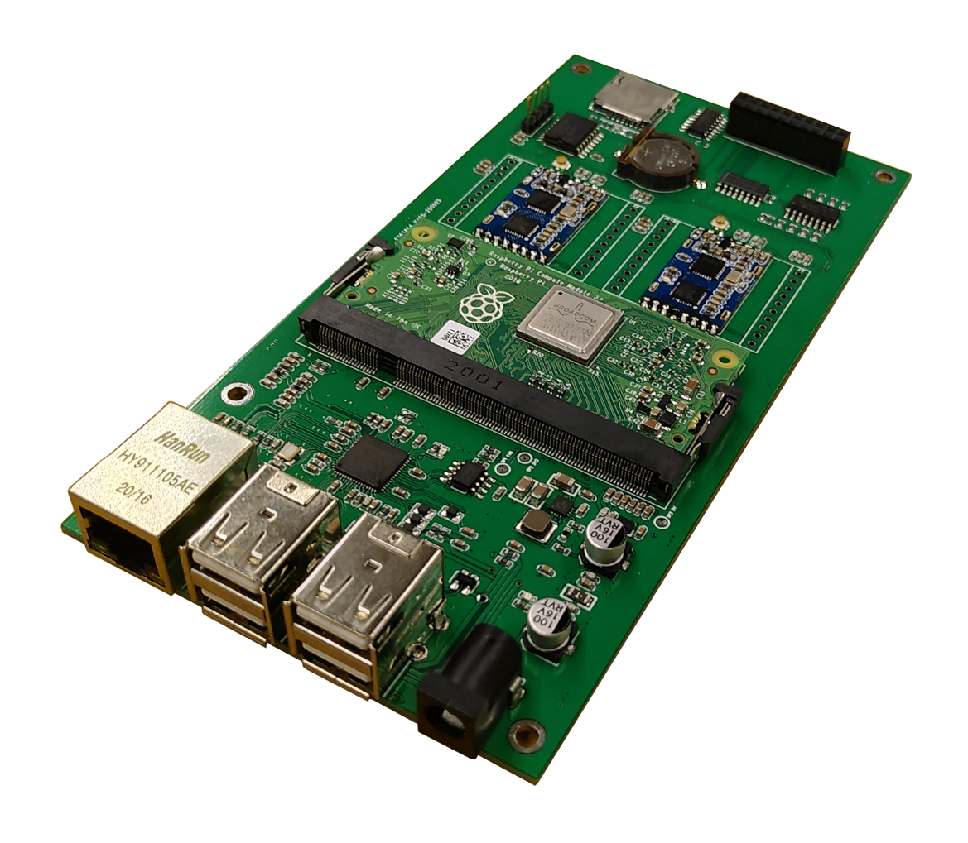

IC Control 500
Flexible RFID System Mainboard

iDTRONIC GmbH  Donnersbergweg 1  67059 Ludwigshafen  Germany/Deutschland  Phone: +49 621 6690094-0  Fax: +49 621 6690094-9  E-Mail: info@idtronic.de  Web: idtronic.de | Issue 1.6  – 05. October 2020 –  Subject to alteration without prior notice.  © Copyright iDTRONIC GmbH 2020  Printed in Germany
Contents
1 Function Description 4
1.1 Overview 4
1.2 Mainboard 4
1.3 Power Supply Circuitry on Main Board 4
1.4 SD/TF Card Slot 4
1.5 Interfaces to RFID electronics 4
1.6 Other Interfaces and Hardware 4
1.7 Other Interfaces and Hardware 5
1.7.1 RTC with DS3231 5
1.7.2 Header for external display SBC-LCD20x4 5
1.8 Protected Outputs 5
1.9 Protected Inputs 5
1.10 Miscellaneous 6
1.11 Illustration of Mainboard with 4 different Versions of RFID 6
2 Housing 8
3 Connections on PCB 9
3.1 Odd numbered PINs on DDR Connector of Raspberry Compute Module 9
3.2 Even numbered PINs on DDR Connector of Raspberry Compute Module 11
4 Ressources 14
5 Revision History 15
6 Technical Data · Preliminary 16

Function Description

Overview
This is intended to be a new mainboard for up to 2 RFID modules or external optical code readers.
The main circuitry is the Raspberry Compute Module 3+.
The main interfacing is the Ethernet + USB-Hub IC LAN9514i.
The Realtek 8188-EU WiFi module provides WiFi.
For other hardware 3 USB ports are available.

Mainboard
- Raspberry Pi Compute Module 3 B+
- 2 × OEM-DES-M900-TTL or
- 2 × Bluebox M900-TTL or
- 1 × Bluebox M950-TTL
- 14 × Digital Outputs protected with NPN transistors (transistor array)
- 4 × Digital Inputs protected with opto-coupler

Power Supply Circuitry on Main Board
Power supply connector socket for 5.5/2.5 mm round plugs.

The Main Board shall provide power supply for the Raspberry Compute 3+
+3.3 Vdc: VBAT, 3V3, GPIO0-27_VREF, GPIO28-45V_REF + HF-RFID 4 A
+1.8 Vdc: 1V8, SDX_VDD 200 mA
+5 Vdc (external): Only for UHF RFID, 2 A
Important Note
Please pay attention to the information in chapter “7.1 Supply Sequencing” in the data sheet “Raspberry Pi Compute Modules 3 (2019).pdf”.

SD/TF Card Slot
SD/TF card slot to GPIO8, GPIO9, GPIO10, GPIO11 (Pins 27, 29, 33, 35)

Interfaces to RFID electronics
2 × TTL:
GPIO14 (configuration: ALT0_TXD0) = RFID1_TXD
GPIO15 (configuration: ALT0_RXD0) = RFID1_RXD

GPIO32 (configuration: ALT5_TXD1) = RFID2_TXD
GPIO33 (configuration: ALT5_RXD1) = RFID2_RXD

Other Interfaces and Hardware
WiFi and Ethernet + USB hub with LAN9514i
The LAN9514i provides 5 USB ports.
Its port USB0 is connected directly to the Raspberry Compute Modules USB port.
Its port USB4 is connected directly to an Realtek 8188-EU WiFi module onboard.

The other 3 USB ports are used freely. This is the job of our configuration and our application software.

Other Interfaces and Hardware
Display-Interface on I²C bus together with RTC. Both devices can be selected by the bus address.

RTC with DS3231
I2C_SDA1 (Pin 9)
I2C_SCL1 (Pin 11)

Header for external display SBC-LCD20x4
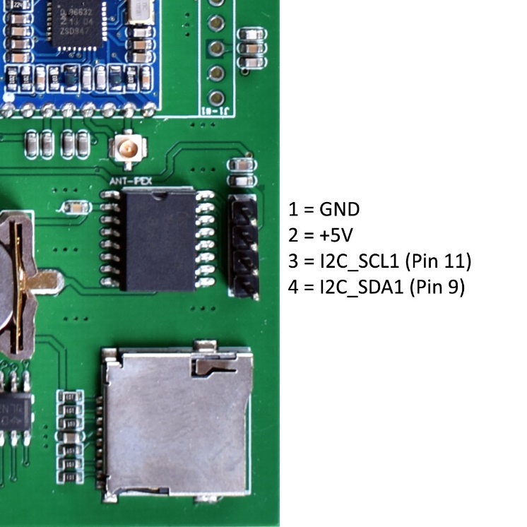

Protected Outputs
6 × for LEDs
4 × for Turnstile Control
Hardware suggestion: 2 Transistor Arrays of 7 ULN-2003A = 14 Outputs, 4 remain unused

Protected Inputs
4 × for PS2501L-4

Miscellaneous

Illustration of Mainboard with 4 different Versions of RFID
Mainboard PCB with 2 × OEM-DES-M900-TTL

Mainboard with 2 × UHF M800-TTL
Mainboard with 2 × UHF M900-TTL
Mainboard with 1 × UHF M950-TTL

Housing
It is intended that this mainboard will be built into a longer version of this housing:
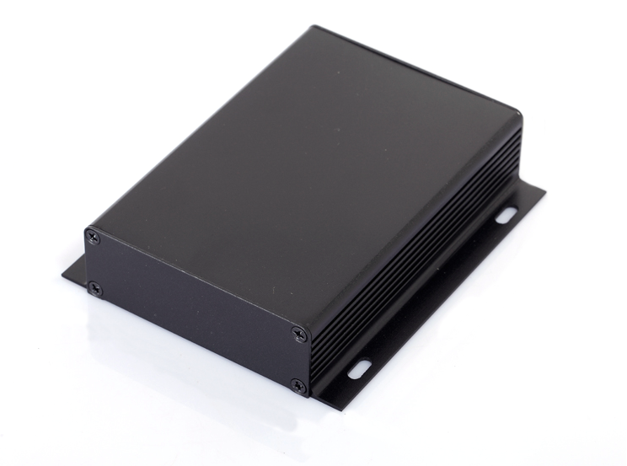

Connections on PCB
SD0 reserved for internal flash memory

Odd numbered PINs on DDR Connector of Raspberry Compute Module
Pin # | Raspberry Designation | Configuration | Function Designation = Net Name | Peripheral Device, Remarks
1 | GND |  | GND
3 | GPIO0 | — | — | DO NOT CONNECT!
5 | GPIO1 | — | — | DO NOT CONNECT!
7 | GND |  | GND
9 | GPIO2 | ALT0_SDA1 | I2C_SDA1 | RTC + Display
11 | GPIO3 | ALT0_SCL1 | I2C_SCL1 | RTC + Display
13 | GND |  | GND
15 | GPIO4 | — | — | —
17 | GPIO5 | — | — | —
19 | GND |  | GND
21 | GPIO6 | — | — | —
23 | GPIO7 | OUTPUT | — | —
25 | GND |  | GND
27 | GPIO8 | OUTPUT | SPI0_CE0_N | SD-Card Enable
29 | GPIO9 | SPI0_MISO | SPI0_MISO | SD-Card MISO
31 | GND |  | GND
33 | GPIO10 | SPI0_MOSI | SPI0_MOSI | SD-Card MOSI
35 | GPIO11 | SPI0_SCLK | SPI0_SCLK | SD-Card CLK
37 | GND |  | GND
39 | GPIO0-27_VDD | — | 3V3 | +3.3 Vdc
KEY
41 | GPIO28-45_VDD | — | 3V3 | +3.3 Vdc
43 | GND |  | GND
45 | GPIO12 | — | — | —
47 | GPIO13 | — | — | —
49 | GND |  | GND
51 | GPIO14 | ALT0_TXD0 | RFID1_TXD | UART0, RFID1
53 | GPIO15 | ALT0_RXD0 | RFID2_RXD | UART0, RFID1
55 | GND |  | GND
57 | GPIO16 | — | — | SD0 reserved!
59 | GPIO17 | — | — | —
61 | GND |  | GND
63 | GPIO18 | — | — | —
65 | GPIO19 | — | — | —
67 | GND |  | GND
69 | GPIO20 | — | — | —
71 | GPIO21 | — | — | —
73 | GND |  | GND
75 | GPIO22 | — | — | —
77 | GPIO23 | — | — | —
79 | GND |  | GND
81 | GPIO24 | — | — | —
83 | GPIO25 | — | — | —
85 | GND |  | GND
87 | GPIO26 | — | — | —
89 | GPIO27 | — | — | —
91 | GND |  | GND
93 | DSI0_DN1 | — | — | —
95 | DSI0_DP1 | — | — | —
97 | GND |  | GND
99 | DSI0_DN0 | — | — | —
101 | DSI0_DP0 | — | — | —
103 | GND |  | GND
105 | DSI0_CN | — | — | —
107 | DSI0_CP | — | — | —
109 | GND |  | GND
111 | HDMI_CLK_N | — | — | —
113 | HDMI_CLK_P | — | — | —
115 | GND |  | GND
117 | HDMI_D0_N | — | — | —
119 | HDMI_D0_P | — | — | —
121 | GND |  | GND
123 | HDMI_D1_N | — | — | —
125 | HDMI_D1_P | — | — | —
127 | GND |  | GND
129 | HDMI_D2_N | — | — | —
131 | HDMI_D2_P | — | — | —
133 | GND |  | GND
135 | CAM1_DP3 | — | — | —
137 | CAM1_DN3 | — | — | —
139 | GND |  | GND
141 | CAM1_DP2 | — | — | —
143 | CAM1_DN2 | — | — | —
145 | GND |  | GND
147 | CAM1_CP | — | — | —
149 | CAM1_CN | — | — | —
151 | GND |  | GND
153 | CAM1_DP1 | — | — | —
155 | CAM1_DN1 | — | — | —
157 | GND |  | GND
159 | CAM1_DP0 | — | — | —
161 | CAM1_DN0 | — | — | —
163 | GND |  | GND
165 | USB_DP | — | USB_DP | USB0+ of LM9514i
167 | USB_DM | — | USB_DM | USB0– of LM9514i
169 | GND |  | GND
171 | HDMI_CEC | — | — | —
173 | HDMI_SDA | — | — | —
175 | HDMI_SCL | — | — | —
177 | RUN | — | — | —
179 | VDD_CORE | — | — | DO NOT CONNECT!
181 | GND |  | GND
183 | 1V8 | — | 1V8 | +1.8 Vdc
185 | 1V8 | — | 1V8 | +1.8 Vdc
187 | GND |  | GND
189 | VDAC | — | 3V3 | +3.3 Vdc, because DAC not in use
191 | 3V3 | — | 3V3 | +3.3 Vdc
193 | 3V3 | — | 3V3 | +3.3 Vdc
195 | GND |  | GND
197 | VBAT | — | 3V3 | +3.3 Vdc
199 | VBAT | — | 3V3 | +3.3 Vdc

Even numbered PINs on DDR Connector of Raspberry Compute Module
Pin # | Raspberry Designation | Configuration | Function Designation = Net Name | Peripheral Device
2 | EMMC_DISABLE_N | —
4 | NC | — | — | —
6 | NC | — | — | —
8 | GND |  | GND
10 | NC | — | — | —
12 | NC | — | — | —
14 | GND |  | GND
16 | NC | — | — | —
18 | NC | — | — | —
20 | GND |  | GND
22 | NC | — | — | —
24 | NC | — | — | —
26 | GND |  | GND
28 | GPIO28 | — |  | Input 1, needs pull-down resistor
30 | GPIO29 | — |  | Input 2, needs pull-down resistor
32 | GND |  | GND
34 | GPIO30 | — |  | Input 3
36 | GPIO31 | — |  | Input 4
38 | GND |  | GND
40 | GPIO0-27_VDD | — | 3V3 | +3.3 Vdc
KEY
42 | GPIO28-45_VDD | — | 3V3 | +3.3 Vdc
44 | GND |  | GND
46 | GPIO32 | ALT5_TXD1 | RFID2_TXD | UART1, RFID2
48 | GPIO33 | ALT5_RXD1 | RFID2_RXD | UART1, RFID2
50 | GND |  | GND
52 | GPIO34 | — | OUT1 | Turnstile LED Control
54 | GPIO35 | — | OUT2 | Turnstile LED Control
56 | GND |  | GND
58 | GPIO36 | — | OUT3 | Turnstile LED Control
60 | GPIO37 | — | OUT4 | Turnstile LED Control
62 | GND |  | GND
64 | GPIO38 | — | OUT5 | Turnstile LED Control
66 | GPIO39 | — | OUT6 | Turnstile LED Control
68 | GND |  | GND
70 | GPIO40 | — | OUT7 | Turnstile Passage Control
72 | GPIO41 | — | OUT8 | Turnstile Passage Control
74 | GND |  | GND
76 | GPIO42 | — | OUT9 | Turnstile Passage Control
78 | GPIO43 | — | OUTA | Turnstile Auxiliary Control
80 | GND |  | GND
82 | GPIO44 | — | PullLow1 | needs pull-down resistor
84 | GPIO45 | — | PullLow2 | needs pull-down resistor
86 | GND |  | GND
88 | HDMI_HPD_N_1V8 | — | — | —
90 | EMMC_EN_N_1V8 | — | — | —
92 | GND |  | GND
94 | DSI1_DP0 | — | — | —
96 | DSI1_DN0 | — | — | —
98 | GND |  | GND
100 | DSI1_CP | — | — | —
102 | DSI1_CN | — | — | —
104 | GND |  | GND
106 | DSI1_DP3 | — | — | —
108 | DSI1_DN3 | — | — | —
110 | GND |  | GND
112 | DSI1_DP2 | — | — | —
114 | DSI1_DN2 | — | — | —
116 | GND |  | GND
118 | DSI1_DP1 | — | — | —
120 | DSI1_DN1 | — | — | —
122 | GND |  | GND
124 | NC | — | — | —
126 | NC | — | — | —
128 | NC | — | — | —
130 | NC | — | — | —
132 | NC | — | — | —
134 | GND |  | GND
136 | CAM0_DP0 | — | — | —
138 | CAM0_DN0 | — | — | —
140 | GND |  | GND
142 | CAM0_CP | — | — | —
144 | CAM0_CN | — | — | —
146 | GND |  | GND
148 | CAM0_DP1 | — | — | —
150 | CAM0_DN1 | — | — | —
152 | GND |  | GND
154 | NC | — | — | —
156 | NC | — | — | —
158 | NC | — | — | —
160 | NC | — | — | —
162 | NC | — | — | —
164 | GND |  | GND
166 | TVDAC | — | — | TV composite output, do not connect
168 | USB_OTGID | — | GND | OTG Pin detect
170 | GND |  | GND
172 | VC_TRST_N | — | — | —
174 | VC_TDI | — | — | —
176 | VC_TMS | — | — | —
178 | VC_TDO | — | — | —
180 | VC_TCK | — | — | —
182 | GND |  | GND
184 | 1V8 | — | 1V8 | +1.8 Vdc
186 | 1V8 | — | 1V8 | +1.8 Vdc
188 | GND |  | GND
190 | VDAC | — | 3V3 | +3.3 Vdc, because DAC not in use
192 | 3V3 | — | 3V3 | +3.3 Vdc
194 | 3V3 | — | 3V3 | +3.3 Vdc
196 | GND |  | GND
198 | VBAT | — | 3V3 | +3.3 Vdc
200 | VBAT | — | 3V3 | +3.3 Vdc

Ressources
https://elinux.org/RPi_BCM2835_GPIOs

https://pi4j.com/1.2/pins/model-cm3-plus-rev1.html

https://www.raspberrypi.org/forums/

https://de.wikipedia.org/wiki/Raspberry_Pi

https://pi4j.com/1.2/pins/model-cm3-plus-rev1.html

https://en.wikipedia.org/wiki/USB_On-The-Go

Revision History
Version | Date | Notes
0.1 | 2019-12-03 | Initial draft with new mainboard
1.0 | 2020-02-07 | First Release
1.1 | 2020-02-24 | Illustration of Hardware added
1.2 | 2020-03-12 | Details changed
1.3 | 2020-05-26 | WiFi on Board removed (GPIO21…27 unused), Header for external LCD added, Miscellaneous Interfaces removed, first note of chapter “Housing” added, SD/TF card slot changed to correct pins.
1.4 | 2020-06-03 | Renamed to ID Control 500, Realtek 8188-EU WiFi module added.

Technical Data · Preliminary
Electrical Specifications
Power Supply | +5 Vdc
Power Consumption | Depending on RFID hardware and devices at USB ports
Interfaces | 1 × Ethernet, 3 × USb
Trigger Input | Opto-coupler PS2501-1, 1.2 V forward voltage @ 10 mA, external resistor needed!
Signal Output | NPN Open-Collector SS8050D, 25 V max, 1.5 A max

Mechanical Specifications
Dimensions
Weight
Material

Applicable Standards
EMC | EN 301489-1:2012-04 (v1.9.21)  EN 301489-3:2013-12 (V1.6.1)
Radio Regulation | EN 300330-1:2015-08 (V1.8.1)  EN 300330-2:2015-08 (V1.6.1)
Safety | EN 60950-1:2014-08  EN 62369-1:2010-03  EN 50364:2010-11
RoHS, REACH | EU Guideline 1907/2006, updated by 2018/2005/EU (REACH)  EU Guideline 2011/65/EU (RoHS 2)  EU Guideline 2015/863/EU (RoHS 3)

SDK Information
Supported OS | Windows XP, Vista, 7, 8, 8.1, 10
Supported Languages | ASCII command protocol, VS2005 C++
Demo Software | Windows

Other functions and details to be continued and upgraded.

